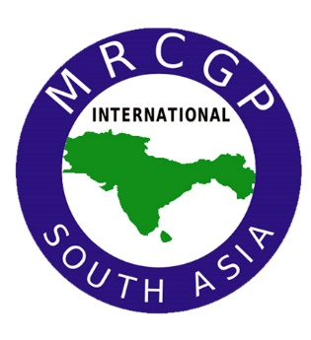
MRCGP [INT.] SOUTH ASIA
International Membership Exam of
Royal College of General Practitioners (RCGP) – UK
Recent passport-size photo
ONLINE EXAM ORIENTATION SESSION
INDIA

Sunday, July 24th, 2022

SESSION REGISTRATION FORM
Full Name:
Gender: | Male □ | Female □
Qualification:
Year of graduation:
Current Job Position:
Duration of Clinical experience: | Family Medicine / GP | Others specialties
Complete Address:
Email:
Contact No:
City:
State:

