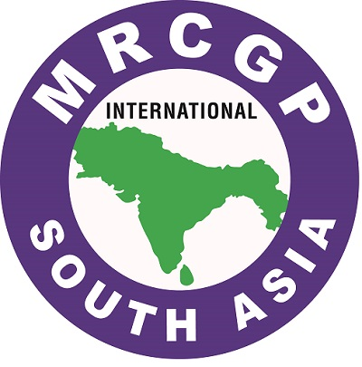

MRCGP [INT] South Asia
Examiner Submission Package – Checklist for Examiners
September 2025 – Sri Lanka

Guidance for applicants applying to MRCGP [INT] Examiners Panel

To supplement your application for appointment to the MRCGP [INT] South Asia OSCE examiners panel, you are required to submit complete contact details of at least two referees.

These referees should normally be one of the following.

- Holder of Postgraduate degree from any of the south Asian member countries (preferably in Family Medicine)
- Having an academic appointment

You are required to send the attached form to each of your referees, inserting your name at the top of the form.

Please note that both referees must not be employed by the same institution.

