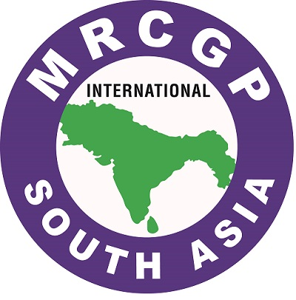

MRCGP [INT] SOUTH ASIA

APPOINTMENT TO THE MRCGP [INT] SOUTH ASIA EXAMINER PANEL
Sri Lanka – September 2025

Referees Checklist
has applied to join the MRCGP [INT] examiners panel and has named you as one of the referees.

We would be most grateful if you could complete this form and inform us, whether in your opinion this applicant has the necessary academic and personal qualifications to undertake the examiner’s role.

ELIGIBILITY CRITERIA

The Examination’s formal requirements in relation to its examiners may be seen as follows:

- Professionally qualified in general practice/family medicine/primary
care (PC), in possession of the MRCGP (UK or International)
or local equivalent qualification
- In good standing with national registration authority and PC accrediting body
- Have been in practice in PC for at least 5 years.
- Currently in practice in PC for at least 50% of their working time
- Up-to-date in their professional knowledge and practice,
and demonstrably committed to their own CPD

PERSON SPECIFICATION

Beyond the willingness to commit to the examination and to devote substantial time to it, for modest recompense, the potential examiner should demonstrate that s/he is:

- Motivated by a wish to improve the delivery of primary care in South Asia.
- Not dogmatic in opinions or attitudes to candidates.

- Prepared to go along with a team consensus (in training and
planning sessions) and adopt the ‘team view’.
- Able to judge candidates dispassionately on basis of performance seen.
- Prepared to receive feedback regarding examining performance, and to act on this.

Remarks:

Referee’s Name (Block letters):

Referee’s Position:

Signature:

Date:

